Name(s): | Prashant Gupta
Scoring Criteria are available at the Moodle submission site. Use these as a checkoff before you submit your work.

The first part of this worksheet will be an essay over your analysis of the design of the Tetris project as laid out by the UML. I am not interested in if you "like" it or not. I want your analysis of how well it adheres to the SOLID acronym.

(40 points) This essay should take the form of discussing each principle that the letters of the Acronym stands for. For each principle you should give an example of where the design adheres to the principle and if it does not, where is does not. You need to include specific well described examples, with well explained reasons for you option. This part will be scored out of 40 points. Any points do not earn will be deducted from your Tetris score.

Example, if you earn 40 /40 points on this essay - no points will be deducted from you score
Example, if you earn 33 /40 points on this essay - 7 points will be deducted from your score.

Start discussion below:
The Tetris project, as laid out by its UML, shows a good understanding of some SOLID principles, particularly SRP, with clear distinctions between different aspects of the game.

Single Responsibility Principle (SRP): Within the Tetris project, individual responsibilities are assigned to classes such as TetrisGame, TetrisDisplay, and TetrisWindow. TetrisGame manages game logic, TetrisDisplay handles rendering Graphics components, and TetrisWindow oversees the application window and user interactions. This division adheres closely to the Single Responsibility Principle (SRP).

Open/Closed Principle (OCP): The project design shows partial adherence to the Open-Closed Principle (OCP). Utilizing the TetrisGame class as a central handler for game logic permits the extension of game features without substantial modifications to the core logic. However, there's room for improvement, such as employing interfaces for game rules or brick behaviors, to fully embody this principle.

Liskov Substitution Principle (LSP): The project design partially aligns with the Open-Closed Principle (OCP). By employing the TetrisGame class as a central handler for game logic, it enables the extension of game features without significant alterations to the core logic. Nevertheless, further enhancements, like integrating interfaces for game rules or brick behaviors, are needed to fully embrace this principle..

Interface Segregation Principle (ISP): The design appears to adhere to the Interface Segregation Principle (ISP) to a certain extent. Each class in the UML diagram has clearly defined responsibilities and doesn't appear to be overloaded with unnecessary methods.

Dependency Inversion Principle (DIP): TetrisDisplay depends on abstract representations of the game state rather than directly on TetrisGame, which is a direct violation of the Dependency Inversion Principle.

In summary, while the Tetris project shows a good understanding of some SOLID principles, there is always room for improvement, especially in terms of extensibility and maintainability. Careful consideration of these principles can significantly enhance the quality and robustness of the design.

UML for your Leader Board: Insert an image of the detailed UML for the LeaderBoard
(20 points) By detailed, I mean the return type and parameter lists for all methods must be included. Any points not earned will be deducted from your Tetris score. Your UML will be evaluated by how well you adhered to it and well it follows OOD.

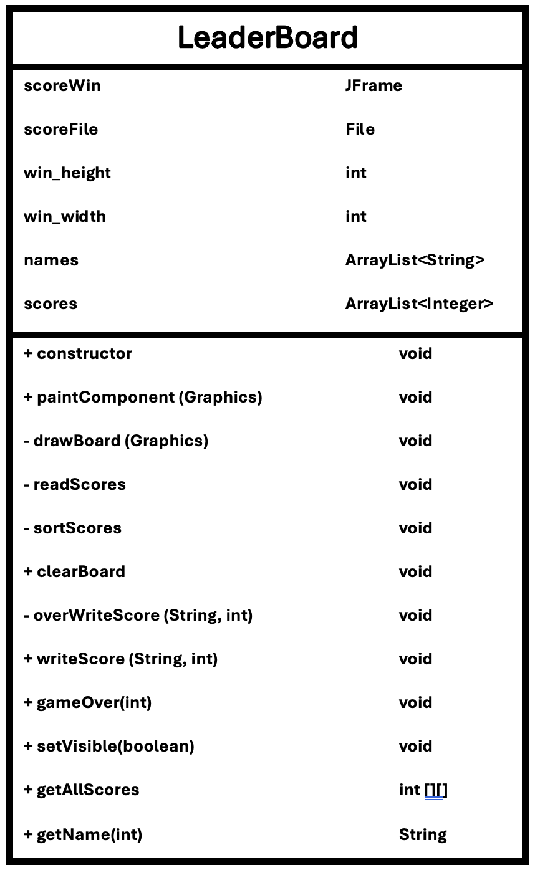
The second part of this report is to include several screen shots of your implement.
- Please, take a screen shot of a position before and after a single row has disappeared.

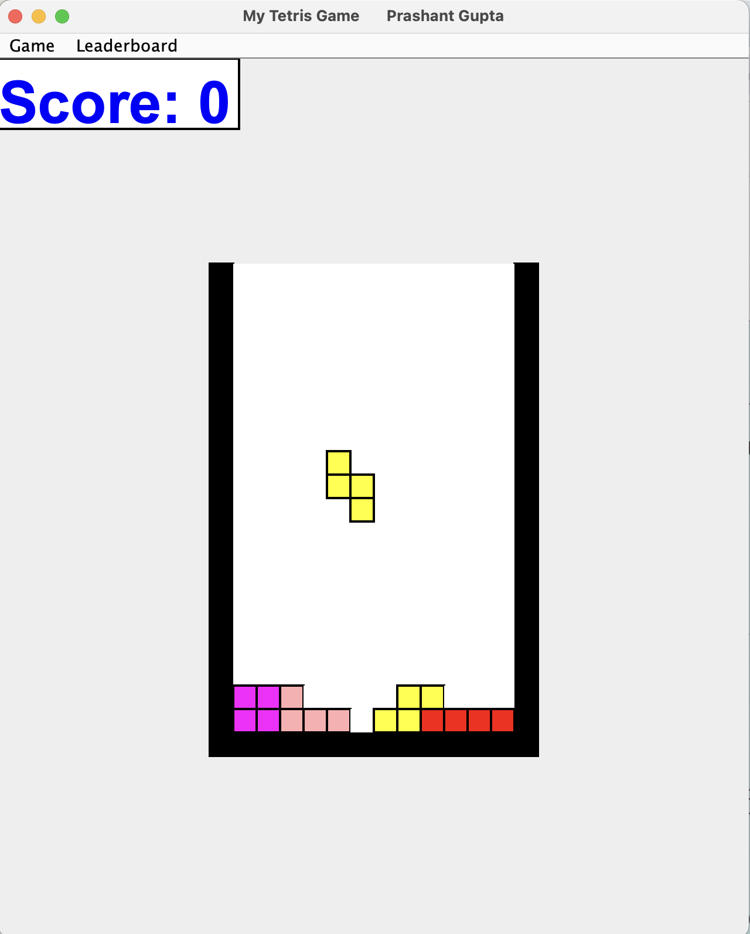

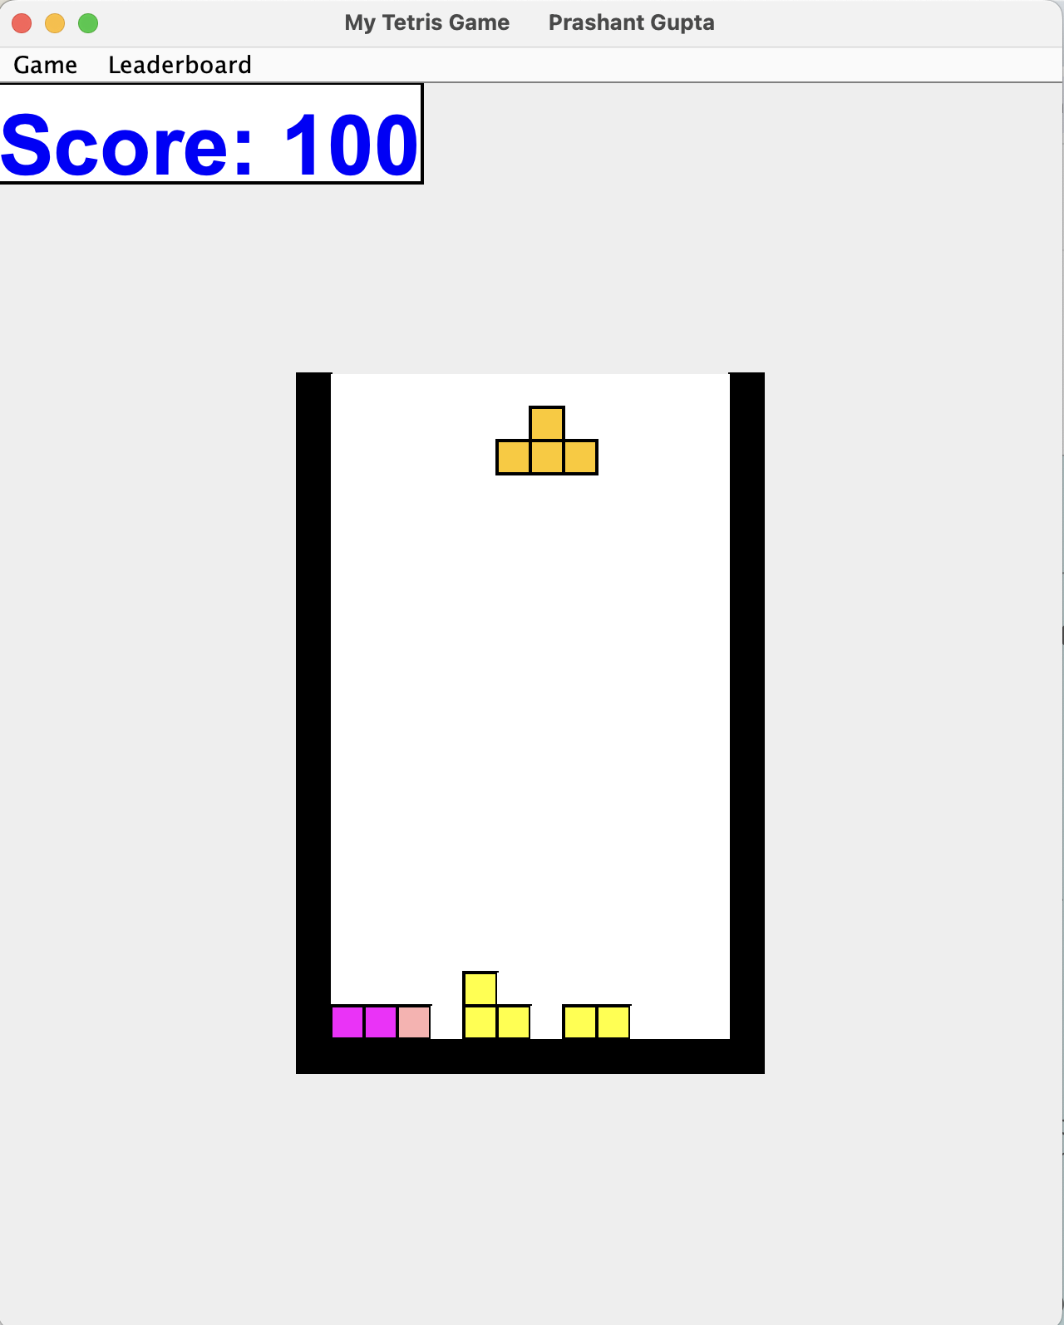
- Please, take a screen shot of a position before and after two rows have disappeared.

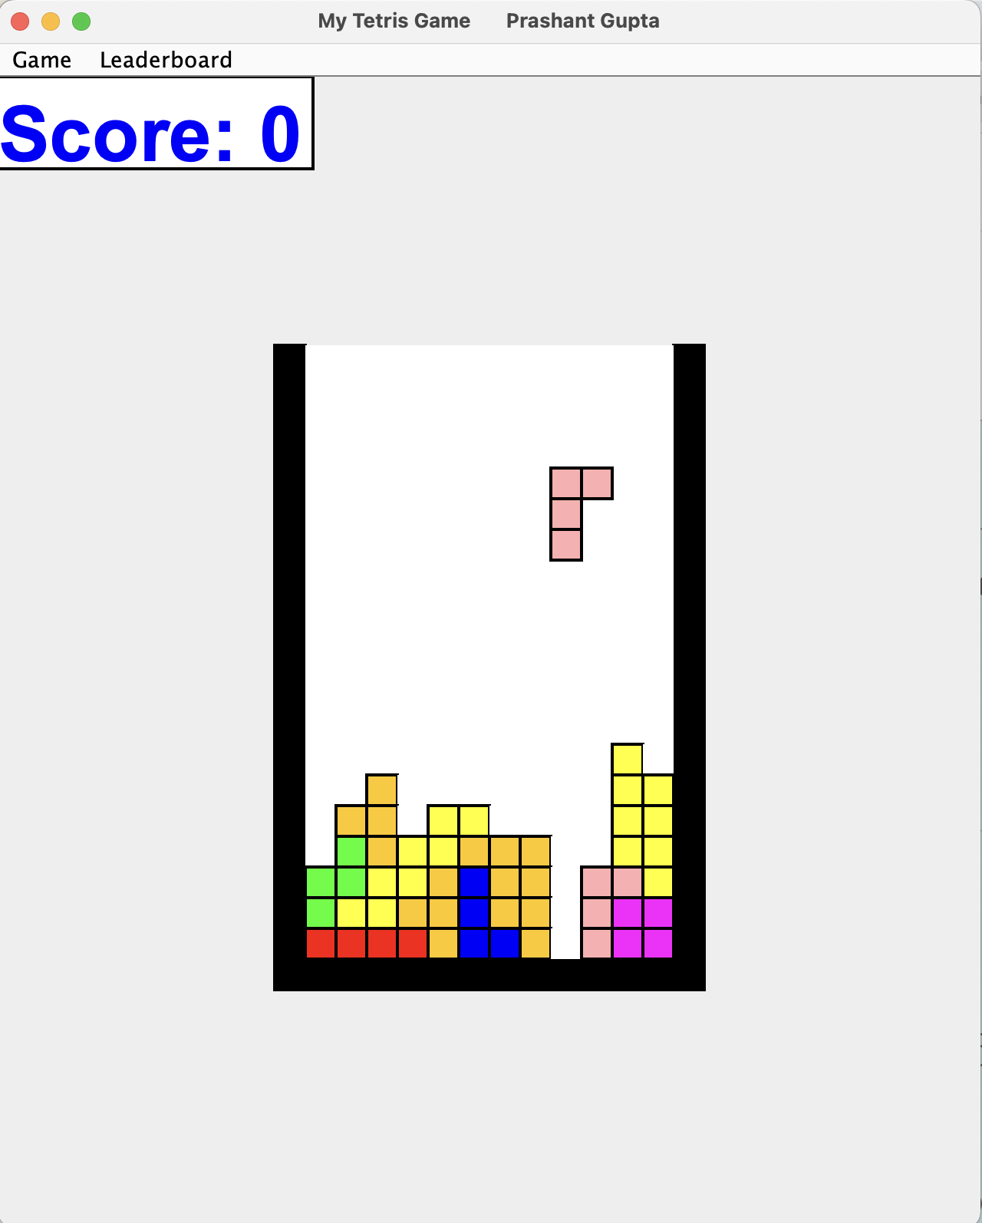

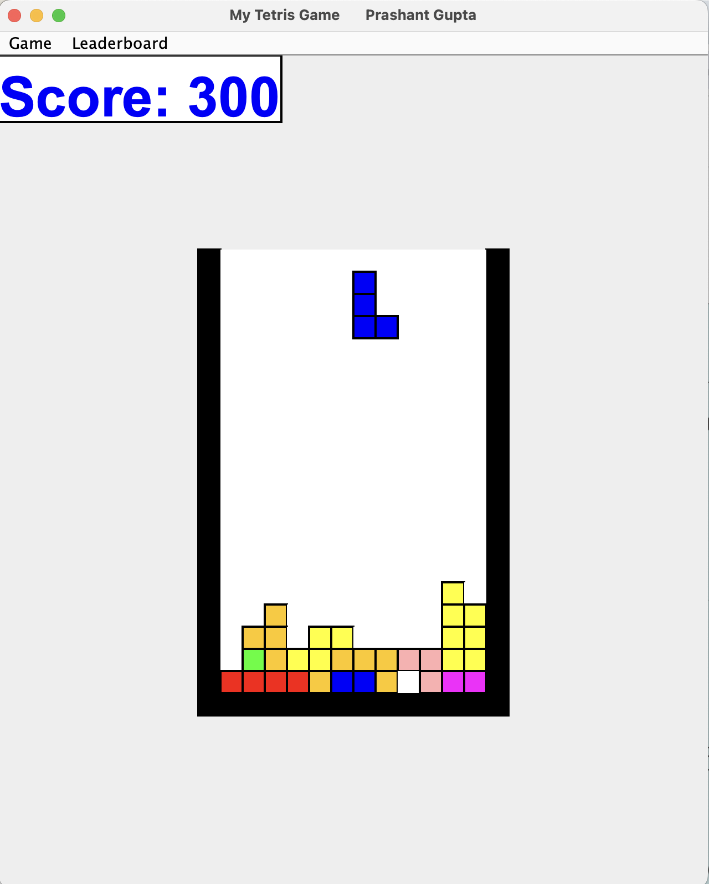

- Please, take a screen shot of a position before and after three rows have disappeared.

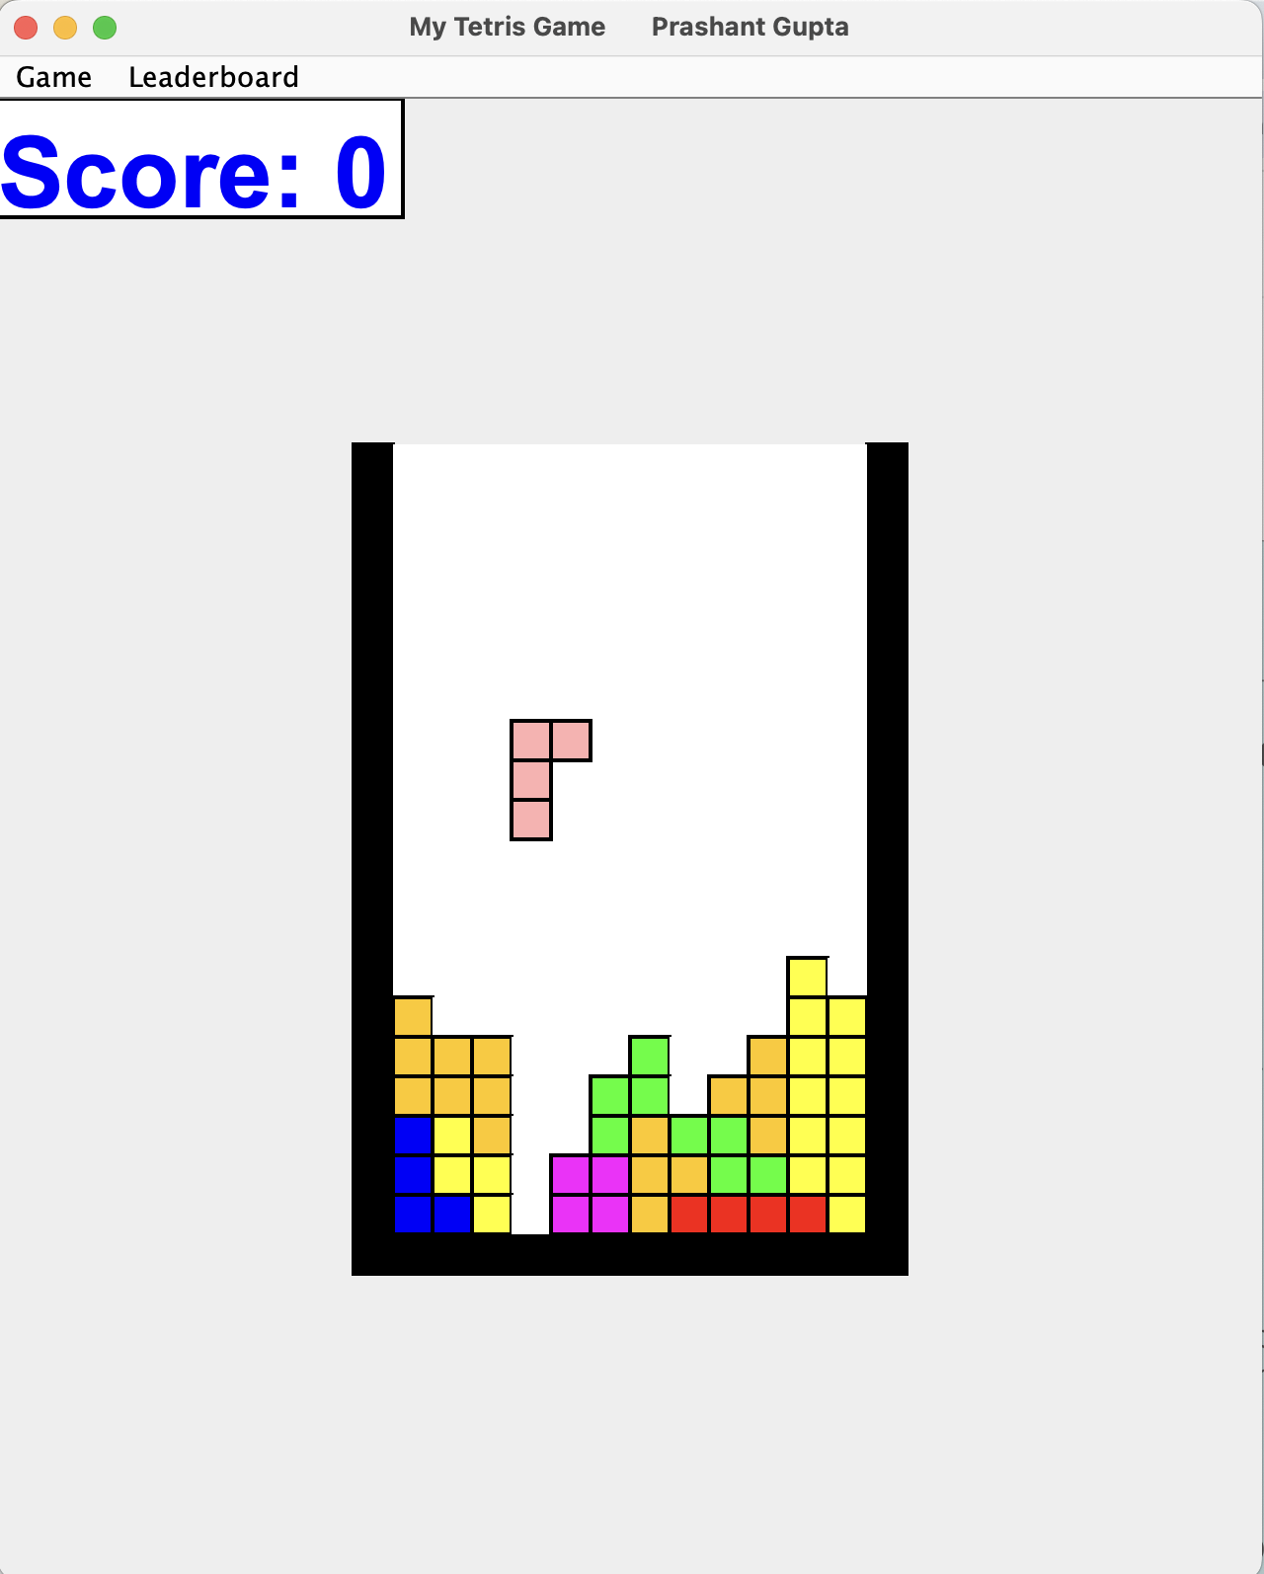

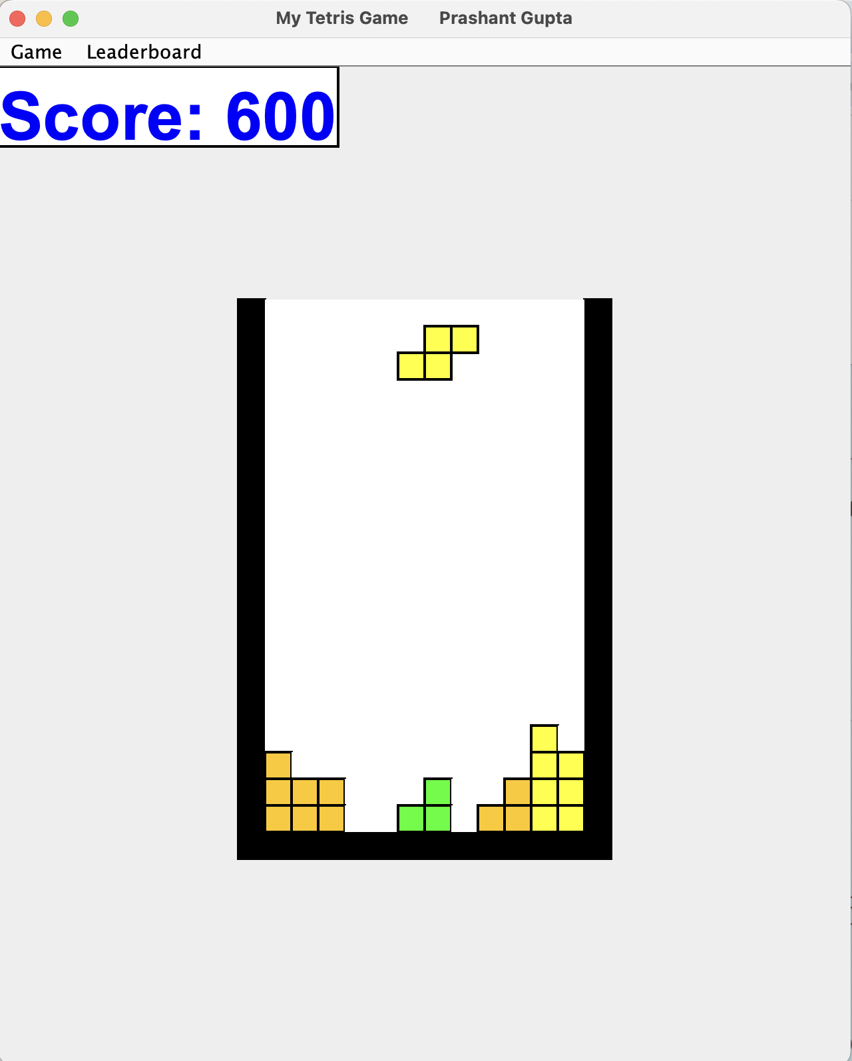
- Please, take a screen shot of a position before and after four rows have disappeared.

